**表1-1 抗原竞争ELISA法猕猴血清EH标准曲线参数**

|  |  |  |  |  |  |
| --- | --- | --- | --- | --- | --- |
| **分析批** | **A1** | **A2** | **x0** | **p** | **相关系数R2** |
| 1 | 1.696 | -0.947 | 3552.395 | 0.398 | 0.998 |
| 2 | 1.862 | -0.701 | 2132.003 | 0.463 | 0.999 |
| 3 | 1.972 | -0.672 | 1843.473 | 0.476 | 0.999 |
| 注：标准曲线方程为y = A2 + (A1-A2)/(1 + (x/x0)^p) | | | | | |



**图1-1. 竞争ELISA法测定猕猴血清EH标准曲线**

**5.2 精密度和准确度**

分别制备10、100、800、6400 ng·mL-1 四个浓度的QC样品，每一浓度进行6样本分析，重复3个分析批，随行标准曲线，以当日的标准曲线计算QC样品的浓度，采用单因素方差分析法计算分析方法的准确度（*RE*）和精密度（*RSD*）。批内精密度为2.0~16.4％、批间精密度为5.9~13.3％，准确度为-0.1~-3.3 %。结果表明EH在浓度10 ~ 6400ng/mL 范围内测定的批内及批间重现性良好，准确度符合要求。结果见表1-2。

**表1-2 ELISA法测定血清EH的准确度和精密度（n=6）**

|  |  |  |  |  |
| --- | --- | --- | --- | --- |
| **实验组** | **EH浓度（ng·mL-1）** | | | |
| **10** | **100** | **800** | **6400** |
| 1 | 10.3 | 93.0 | 782.5 | 6161.0 |
| 8.0 | 78.4 | 733.5 | 5894.6 |
| 12.8 | 88.5 | 690.1 | 5849.5 |
| 12.1 | 101.6 | 756.9 | 5951.5 |
| 9.8 | 102.2 | 820.8 | 6149.2 |
| 8.5 | 106.6 | 824.2 | 6184.8 |
| 2 | 8.4 | 113.7 | 819.5 | 6416.7 |
| 7.6 | 121.8 | 745.8 | 6325.2 |
| 9.5 | 108.5 | 764.7 | 6348.0 |
| 11.0 | 102.9 | 891.7 | 6325.2 |
| 11.4 | 104.5 | 865.5 | 6201.8 |
| 8.5 | 85.7 | 823.8 | 6168.6 |
| 3 | 8.7 | 94.0 | 788.5 | 6148.0 |
| 10.1 | 89.8 | 780.7 | 6244.3 |
| 9.5 | 93.0 | 815.0 | 6190.6 |
| 10.7 | 99.8 | 845.1 | 6287.6 |
| 9.6 | 101.8 | 899.5 | 6397.5 |
| 7.2 | 108.8 | 742.7 | 6430.8 |
| n | 18 | 18 | 18 | 18 |
| mean（ng·mL-1） | 9.7 | 99.7 | 799.5 | 6204.2 |
| SD（ng·mL-1） | 1.6 | 10.7 | 56.1 | 169.4 |
| 批内*RSD*（%） | 16.4 | 10.1 | 6.8 | 2.0 |
| 批间*RSD*（%） | 13.3 | 14.2 | 8.4 | 5.9 |
| *R.E.*（%） | -3.3 | -0.3 | -0.1 | -3.1 |

Mean：平均值；SD：标准差

**5.3 稳定性**

制备10、100 、800 和6400 ng/mL 四个浓度的血清样品，分别考察在-20℃放置8个月稳定性以及反复冻融3次稳定性。同时考察EH储备液（20 mg/mL）4℃放置3个月稳定性。结果表明EH血清样品在-20℃放置8个月、反复冻融3次均稳定，*RE*%分别在-12.8~5.8%和-8.3~6.4 %之间；20 mg·mL-1EH储备液4℃放置3个月稳定，*RE*%为-0.3%。结果分别见表1-3、表1-4和表1-5。

**表1-3 EH血清样品-20℃放置8个月稳定性（n=5）**

|  |  |  |  |  |
| --- | --- | --- | --- | --- |
| 理论值(ng·mL-1) | 10 | 100 | 800 | 6400 |
| 实测值(ng·mL-1) | 12.1 | 87.0 | 827.4 | 6459.3 |
| 11.4 | 85.7 | 812.9 | 6298.9 |
| 10.1 | 87.9 | 903.7 | 6161.8 |
| 7.9 | 86.6 | 859.9 | 6046.9 |
| 10.5 | 88.8 | 830.1 | 5924.9 |
| mean | 10.4 | 87.2 | 846.8 | 6178.4 |
| SD | 1.6 | 1.2 | 36.1 | 209.3 |
| *RSD*% | 15.3 | 1.4 | 4.3 | 3.4 |
| *RE*% | 4.1 | -12.8 | 5.8 | -3.5 |

**表1-4 EH血清样品反复冻融3次稳定性（n=5）**

|  |  |  |  |  |
| --- | --- | --- | --- | --- |
| 理论值(ng·mL-1) | 10 | 100 | 800 | 6400 |
| 实测值(ng·mL-1) | 10.9 | 97.6 | 911.4 | 6069.4 |
| 11.6 | 98.4 | 901.3 | 6086.7 |
| 9.9 | 92.5 | 856.7 | 6139.0 |
| 9.8 | 78.1 | 793.2 | 6095.4 |
| 9.9 | 92.0 | 794.5 | 6174.2 |
| mean | 10.4 | 91.7 | 851.4 | 6113.0 |
| SD | 0.8 | 8.1 | 56.4 | 42.8 |
| *RSD*% | 7.7 | 8.9 | 6.6 | 0.7 |
| *RE*% | 4.2 | -8.3 | 6.4 | -4.5 |

**表1-5 EH储备液4℃放置3个月稳定性（n=6）**

|  |  |
| --- | --- |
| 理论值(ng·mL-1) | 1600 |
| 实测值(ng·mL-1) | 1573.8 |
| 1531.3 |
| 1492.8 |
| 1573.8 |
| 1665.2 |
| 1737.9 |
| mean | 1595.8 |
| SD | 90.3 |
| *RSD*% | 5.7 |
| *RE*% | -0.3 |

注：将20 mg·mL-1EH储备液先用注射用水稀释至2 mg·mL-1，再用空白猴血清稀释至1600 ng·mL-1检测。

**5.4** **稀释效应**

分别考察了猕猴血清加入EH标准品稀释16倍、256倍和10000倍后的准确度。结果表明实测浓度偏差RE%在-0.3~-2.2％之间，无稀释效应。即EH样品最大稀释10000倍以内不会对测定造成显著影响，结果见表1-6。

**表1-6 EH血清样品稀释效应（n=6）**

|  |  |  |  |
| --- | --- | --- | --- |
| 理论浓度(ng·mL-1) | **25(稀释256倍)** | **400(稀释16倍)** | **1600(稀释10000倍)** |
| 实测浓度(ng·mL-1) | 24.3 | 326.0 | 1577.8 |
| 23.2 | 353.1 | 1535.6 |
| 24.5 | 382.9 | 1538.1 |
| 26.2 | 401.8 | 1590.4 |
| 25.8 | 452.9 | 1615.9 |
| 24.9 | 430.1 | 1716.7 |
| mean | 24.8 | 391.1 | 1595.7 |
| SD | 1.1 | 47.3 | 66.8 |
| RSD% | 4.4 | 12.1 | 4.2 |
| RE% | -0.6 | -2.2 | -0.3 |

**5.5 天然水蛭素响应性**

考察了天然水蛭素hirudin在此ELISA方法中的响应性。同“3.2”项下所述分别平行配制EH和hirudin的猴血清标准曲线，结果显示hirudin在10~6400ng/ml浓度范围内与EH有近似的响应度，二者拟合得到的logistic四参数方程和拟合曲线分别见表1-7和图1-2。提示此ELISA方法可同时检测生物样品中的EH及可能存在的活性代谢产物hirudin。

**表1-7 EH和天然水蛭素hirudin的竞争ELISA标准曲线比较**

|  |  |  |  |  |  |
| --- | --- | --- | --- | --- | --- |
|  | **A1** | **A2** | **x0** | **p** | **相关系数R2** |
| EH | 1.86618 | -0.81207 | 2054.50221 | 0.42771 | 0.99875 |
| hirudin | 2.15495 | -1.62915 | 5116.03761 | 0.30696 | 0.99599 |
| 注：标准曲线方程为y = A2 + (A1-A2)/(1 + (x/x0)^p)  图片1 | | | | | |

**图1-2. EH和天然水蛭素hirudin的竞争ELISA标准曲线比较**

**7.1 猕猴单次静脉推注加滴注EH后血清药物浓度和动力学参数**

表2-1~2-3分别是猕猴静脉推注加滴注1.0，3.0和6.0 mg·kg-1 EH后每组个体及平均血清EH浓度。表2-4~2-7为猕猴单次静脉推注加滴注1.0，3.0和6.0 mg·kg-1 EH后每组个体及平均动力学参数。图2-1~2-4为单次静脉推注加滴注不同剂量EH后的血清药物浓度-时间变化曲线及平均药时曲线图。

**表2-1 猕猴单次静脉推注加滴注1.0 mg·kg-1 EH后的血药浓度(ng·mL-1)**

|  |  |  |  |  |  |  |
| --- | --- | --- | --- | --- | --- | --- |
| 时间（h） | 9# | 10# | 11# | 12# | 平均值 | 标准差 |
| 0 | ND | ND | ND | ND |  |  |
| 0.05 | 4146.2 | 7419.2 | 5531.6 | 5414.8 | 5627.9 | 1348.9 |
| 0.55 | 1451.6 | 3470.4 | 1377.9 | 2112.8 | 2103.2 | 969.5 |
| 1.05 | 1908.0 | 3392.5 | 1753.4 | 2158.2 | 2303.0 | 745.2 |
| 1.13 | 880.8 | 2521.3 | 1472.1 | 1534.9 | 1602.3 | 679.9 |
| 1.30 | 543.5 | 1324.3 | 987.9 | 823.4 | 919.8 | 326.2 |
| 1.55 | 482.9 | 937.0 | 637.3 | 509.7 | 641.7 | 208.1 |
| 2.05 | 431.6 | 596.4 | 563.3 | 453.3 | 511.1 | 81.0 |
| 3.05 | 265.3 | 275.3 | 137.4 | 364.6 | 260.7 | 93.5 |
| 5.05 | 90.5 | 124.3 | 49.2 | 96.0 | 90.0 | 30.9 |
| 7.05 | 61.6 | 145.0 | 29.9 | 65.8 | 75.6 | 49.0 |
| 9.05 | 47.0 | 102.1 | 26.3 | 14.8 | 47.5 | 38.7 |
| 13.05 | 27.4 | 3.6 | 14.0 | 10.0 | 13.8 | 10.1 |
| 25.05 | 14.0 | 84.2 | ND | ND | 49.1 | - |

ND: 未检测到；阴影部分数据低于定量下限，仅供作图参考，不参与参数计算。

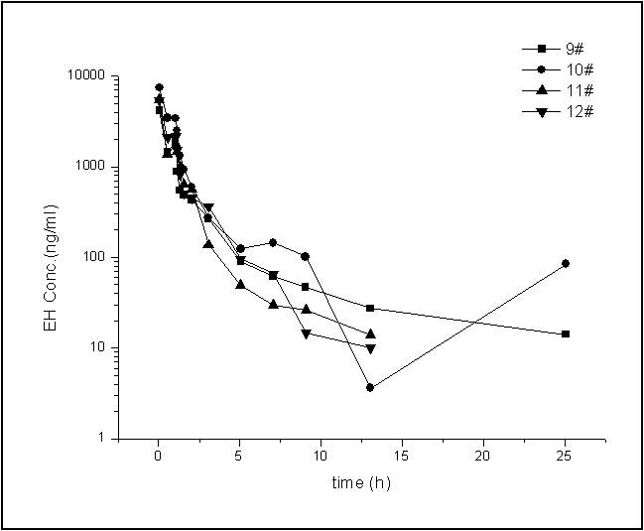

**图2-1 猕猴单次静脉推注加滴注1.0 mg·kg-1 EH后的药时曲线图**

**表2-2 猕猴单次静脉推注加滴注3.0 mg·kg-1 EH后的血药浓度(ng·mL-1)**

|  |  |  |  |  |  |  |
| --- | --- | --- | --- | --- | --- | --- |
| 时间（h） | 1# | 2# | 3# | 4# | 平均值 | 标准差 |
| 0 | ND | ND | ND | ND |  |  |
| 0.05 | 10271.4 | 11850.2 | 10299.2 | 10575.1 | 10749.0 | 746.9 |
| 0.55 | 4873.8 | 4328.5 | 9765.2 | 5365.8 | 6083.3 | 2490.9 |
| 1.05 | 5411.8 | 8327.9 | 7324.3 | 7218.7 | 7070.7 | 1213.6 |
| 1.13 | 3542.6 | 7402.1 | 5795.3 | 2424.3 | 4791.1 | 2235.0 |
| 1.30 | 2428.4 | 5066.3 | 3700.1 | 1584.9 | 3194.9 | 1520.7 |
| 1.55 | 1847.0 | 4328.5 | 2694.5 | 823.0 | 2423.2 | 1482.8 |
| 2.05 | 845.1 | 1345.8 | 1944.5 | 1541.0 | 1419.1 | 456.7 |
| 3.05 | 659.9 | 2362.8 | 1372.4 | 564.7 | 1240.0 | 830.8 |
| 5.05 | 279.3 | 718.1 | 97.2 | 298.5 | 348.3 | 262.7 |
| 7.05 | 12.6 | 378.3 | 32.0 | 19.0 | 110.5 | 178.7 |
| 9.05 | ND | 20.3 | 5.0 | ND | 12.6 | - |
| 13.05 | ND | 2.4 | 19.8 | ND | 11.1 | - |
| 25.05 | ND | 21. 8 | ND | ND | 21.8 | - |

ND: 未检测到；阴影部分数据低于定量下限，仅供作图参考，不参与参数计算。

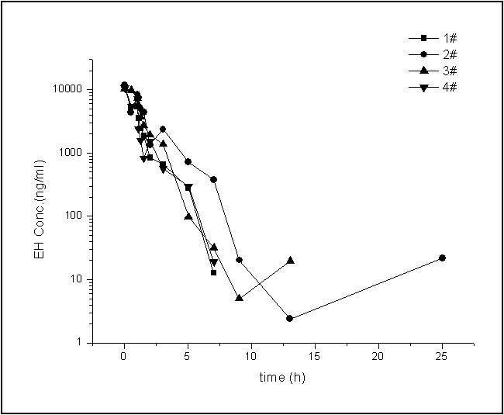

**图2-2 猕猴单次静脉推注加滴注3.0 mg·kg-1 EH后的药时曲线图**

**表2-3 猕猴单次静脉推注加滴注6.0mg·kg-1 EH后的血药浓度(ng·mL-1)**

|  |  |  |  |  |  |  |
| --- | --- | --- | --- | --- | --- | --- |
| 时间（h） | 5# | 6# | 7# | 8# | 平均值 | 标准差 |
| 0 | ND | ND | ND | ND |  |  |
| 0.05 | 37825.7 | 24980.5 | 34109.0 | 30527.4 | 31860.7 | 5469.6 |
| 0.55 | 16044.7 | 13068.2 | 18776.2 | 16392.2 | 16070.3 | 2340.9 |
| 1.05 | 16834.5 | 13323.2 | 16031.8 | 16548.3 | 15684.4 | 1608.8 |
| 1.13 | 13936.2 | 9260.9 | 11430.0 | 12142.7 | 11692.5 | 1933.7 |
| 1.30 | 9361.6 | 6536.1 | 8646.8 | 8380.9 | 8231.4 | 1203.6 |
| 1.55 | 4945.7 | 3362.2 | 4684.8 | 6755.6 | 4937.1 | 1396.6 |
| 2.05 | 6394.8 | 2523.9 | 4402.4 | 5367.9 | 4672.2 | 1647.2 |
| 3.05 | 2213.7 | 1903.2 | 1738.8 | 1984.1 | 1959.9 | 197.6 |
| 5.05 | 655.5 | 275.6 | 186.6 | 393.3 | 377.7 | 203.6 |
| 7.05 | 487.1 | 70.0 | 33.5 | 137.7 | 182.1 | 207.9 |
| 9.05 | 211.5 | 35.1 | ND | 70.9 | 105.8 | 93.2 |
| 13.05 | 83.0 | 19.2 | ND | 44.9 | 49.0 | 32.1 |
| 25.05 | 33.3 | ND | ND | 19.1 | 26.2 | - |

ND: 未检测到。

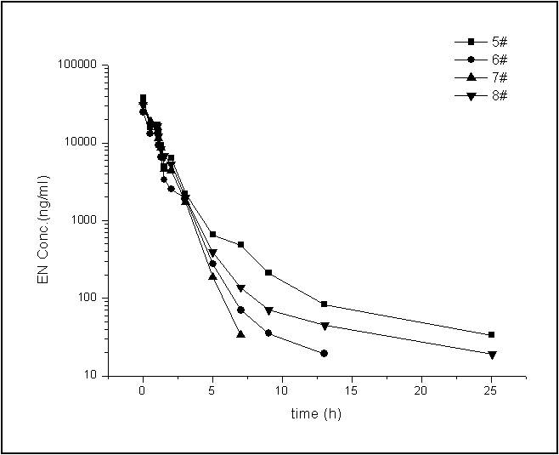

**图2-3 猕猴单次静脉推注加滴注6.0 mg·kg-1 EH后的药时曲线图**

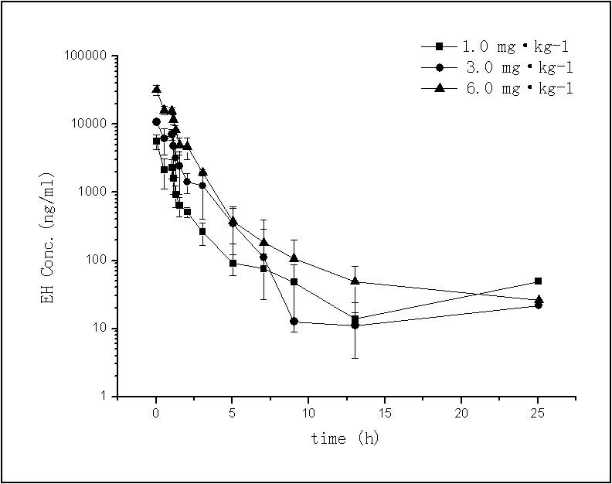

**图2-4 猕猴单次静脉推注加滴注1.0、3.0、6.0 mg·kg-1 EH后平均药时曲线图**

**（均值±标准差，n = 4）**

**表2-4 猕猴单次静脉推注加滴注1.0 mg·kg-1 EH后的药动学参数**

|  |  |  |  |  |  |  |  |
| --- | --- | --- | --- | --- | --- | --- | --- |
| 参数 | 单位 | 9# | 10# | 11# | 12# | 平均数 | 标准差 |
| ke | 1·h-1 | 0.4 | 0.9 | 1.1 | 0.4 | 0.7 | 0.3 |
| ke_lower | h | 1.3 | 1.3 | 1.3 | 1.3 | 1.3 | 0.0 |
| ke_upper | h | 3.05 | 3.05 | 3.05 | 3.05 | 3.05 | 0.0 |
| t1/2 | h | 1.7 | 0.8 | 0.6 | 1.8 | 1.2 | 0.6 |
| Tmax | h | 0.05 | 0.05 | 0.05 | 0.05 | 0.05 | 0.0 |
| Cmax | ng·ml-1 | 4146.2 | 7419.2 | 5531.6 | 5414.8 | 5628.0 | 1348.9 |
| AUClast | h·ng·ml-1 | 4115.5 | 8505.3 | 3933.0 | 4791.3 | 5336.3 | 2144.7 |
| AUCINF_obs | h·ng·ml-1 | 4150.3 | 8601.8 | 3945.9 | 4817.2 | 5378.8 | 2180.7 |
| Vz_obs | L·kg-1 | 0.6 | 0.1 | 0.2 | 0.5 | 0.4 | 0.2 |
| Cl_obs | L·h-1·kg-1 | 0.2 | 0.1 | 0.3 | 0.2 | 0.2 | 0.1 |
| MRTlast | h | 2.3 | 3.6 | 0.9 | 1.0 | 1.9 | 1.3 |

**表2-5 猕猴单次静脉推注加滴注3.0 mg·kg-1 EH后的药动学参数**

|  |  |  |  |  |  |  |  |
| --- | --- | --- | --- | --- | --- | --- | --- |
| 参数 | 单位 | 1# | 2# | 3# | 4# | 平均数 | 标准差 |
| ke | 1·h-1 | 0.7 | 0.5 | 0.5 | 0.5 | 0.5 | 0.1 |
| ke_lower | h | 1.3 | 1.3 | 1.3 | 1.3 | 1.3 | 0.0 |
| ke_upper | h | 3.05 | 3.05 | 3.05 | 3.05 | 3.05 | 0.0 |
| t1/2 | h | 0.9 | 1.5 | 1.3 | 1.5 | 1.3 | 0.3 |
| Tmax | h | 0.05 | 0.05 | 0.05 | 0.05 | 0.05 | 0.0 |
| Cmax | ng·ml-1 | 10271.4 | 11850.2 | 10299.2 | 10575.1 | 10749.0 | 746.8 |
| AUClast | h·ng·ml-1 | 10283.4 | 17426.8 | 15655.3 | 10795.6 | 13540.3 | 3545.8 |
| AUCINF_obs | h·ng·ml-1 | 10300.4 | 17474.3 | 15692.5 | 10837.7 | 13576.2 | 3554.6 |
| Vz_obs | L·kg-1 | 0.4 | 0.4 | 0.4 | 0.6 | 0.4 | 0.1 |
| Cl_obs | L·h-1·kg-1 | 0.3 | 0.2 | 0.2 | 0.3 | 0.2 | 0.1 |
| MRTlast | h | 0.7 | 1.7 | 0.7 | 0.7 | 1.0 | 0.5 |

**表2-6 猕猴单次静脉推注加滴注6.0 mg·kg-1 EH后的药动学参数**

|  |  |  |  |  |  |  |  |
| --- | --- | --- | --- | --- | --- | --- | --- |
| 参数 | 单位 | 5# | 6# | 7# | 8# | 平均数 | 标准差 |
| ke | 1·h-1 | 0.7 | 0.6 | 0.8 | 0.8 | 0.7 | 0.1 |
| ke_lower | h | 1.3 | 1.3 | 1.3 | 1.3 | 1.3 | 0.0 |
| ke_upper | h | 3.05 | 3.05 | 3.05 | 3.05 | 3.05 | 0.0 |
| t1/2 | h | 1.0 | 1.2 | 0.8 | 0.9 | 1.0 | 0.1 |
| Tmax | h | 0.05 | 0.05 | 0.05 | 0.05 | 0.05 | 0.0 |
| Cmax | ng·ml-1 | 37825.7 | 24980.5 | 34109.0 | 30527.4 | 31860.7 | 5469.6 |
| AUClast | h·ng·ml-1 | 39106.4 | 25694.3 | 33498.3 | 34787.6 | 33271.7 | 5592.0 |
| AUCINF_obs | h·ng·ml-1 | 39153.3 | 25726.3 | 33539.0 | 34811.1 | 33307.4 | 5596.5 |
| Vz_obs | L·kg-1 | 0.2 | 0.4 | 0.2 | 0.2 | 0.3 | 0.1 |
| Cl_obs | L·h-1·kg-1 | 0.2 | 0.2 | 0.2 | 0.2 | 0.2 | 0.0 |
| MRTlast | h | 1.3 | 0.7 | 0.5 | 1.0 | 0.9 | 0.4 |

**表2-7 猕猴单次静脉推注加滴注1.0、3.0、6.0 mg·kg-1 EH后的平均药动学参数**

|  |  |  |  |  |
| --- | --- | --- | --- | --- |
| 参数 | 单位 | 1.0 mg·kg-1 | 3.0 mg·kg-1 | 6.0 mg·kg-1 |
| ke | 1·h-1 | 0.7± 0.3 | 0.5±0.1 | 0.7±0.1 |
| ke_lower | h | 1.3±0.0 | 1.3±0.0 | 1.3±0.0 |
| ke_upper | h | 3.05±0.00 | 3.05±0.00 | 3.05±0.00 |
| t1/2 | h | 1.2±0.6 | 1.3±0.3 | 1.0±0.1 |
| Tmax | h | 0.05±0.00 | 0.05±0.00 | 0.05±0.00 |
| Cmax | ng·ml-1 | 5628.0±1348.9 | 10749.0±746.8 | 31860.7±5469.6 |
| AUClast | h·ng·ml-1 | 5336.3±2144.7 | 13540.3±3545.8 | 33271.7±5592.0 |
| AUCINF_obs | h·ng·ml-1 | 5378.8±2180.7 | 13576.2±3554.6 | 33307.4±5596.5 |
| Vz_obs | L·kg-1 | 0.4±0.2 | 0.4±0.1 | 0.3±0.1 |
| Cl_obs | L·h-1·kg-1 | 0.2±0.1 | 0.2±0.1 | 0.2±0.0 |
| MRTlast | h | 1.9±1.3 | 1.0±0.5 | 0.9±0.4 |

注：动力学参数ke、t1/2、MRTlast、Vz_obs和Cl_obs经方差分析各剂量组间差异均无统计学意义，P>0.05.

**7.2 猕猴连续静脉推注加滴注EH后血清药物浓度和动力学参数**

猕猴每天静脉推注加滴注 3.0 mg·kg-1 EH 1次，连续7天，个体及平均血药浓度数据见表2-8，表2-9为猕猴连续静脉推注加滴注EH第1次和第7次后的动力学参数。图2-5~2-6分别为猕猴每天1次，连续7天静脉推注加滴注3.0 mg·kg-1 EH后的平均血药浓度-时间曲线图及第1次和第7次的平均药时曲线比较图。

**表2-8 猕猴连续静脉推注加滴注3.0 mg·kg-1 EH的血药浓度(ng·mL-1)**

|  |  |  |  |  |  |  |  |
| --- | --- | --- | --- | --- | --- | --- | --- |
| 时间（d） | 时间（h） | 1# | 2# | 3# | 4# | 平均值 | 标准差 |
| 1 | 0 | ND | ND | ND | ND |  |  |
|  | 0.05 | 10271.4 | 11850.2 | 10299.2 | 10575.1 | 10749.0 | 746.9 |
|  | 0.55 | 4873.8 | 4328.5 | 9765.2 | 5365.8 | 6083.3 | 2490.9 |
|  | 1.05 | 5411.8 | 8327.9 | 7324.3 | 7218.7 | 7070.7 | 1213.6 |
|  | 1.13 | 3542.6 | 7402.1 | 5795.3 | 2424.3 | 4791.1 | 2235.0 |
|  | 1.3 | 2428.4 | 5066.3 | 3700.1 | 1584.9 | 3194.9 | 1520.7 |
|  | 1.55 | 1847.0 | 4328.5 | 2694.5 | 823.0 | 2423.2 | 1482.8 |
|  | 2.05 | 845.1 | 1345.8 | 1944.5 | 1541.0 | 1419.1 | 456.7 |
|  | 3.05 | 659.9 | 2362.8 | 1372.4 | 564.7 | 1240.0 | 830.8 |
|  | 5.05 | 279.3 | 718.1 | 97.2 | 298.5 | 348.3 | 262.7 |
|  | 7.05 | 12.6 | 378.3 | 32.0 | 19.0 | 110.5 | 178.7 |
|  | 9.05 | ND | 20.3 | ND | ND | 20.3 | - |
|  | 13.05 | ND | ND | 19.8 | ND | 19.8 | - |
| 2 | 25.05 | ND | 21.8 | ND | ND | 21.8 | - |
|  | 25.1 | 15093.4 | 12251.8 | 16717.6 | 13787.0 | 14462.5 | 1899.7 |
|  | 26.1 | 9660.4 | 7710.2 | 7105.0 | 7356.3 | 7958.0 | 1161.8 |
| 3 | 49 | 5.9 | ND | ND | ND | 5.9 | - |
|  | 49.05 | 15135.8 | 10909.8 | 13092.7 | 11540.2 | 12669.6 | 1882.7 |
|  | 50.05 | 8845.4 | 5356.4 | 6252.0 | 5594.4 | 6512.1 | 1601.0 |
| 4 | 73 | 35.3 | 7.7 | 0.3 | ND | 14.4 | 18.4 |
|  | 73.05 | 13683.5 | 9380.8 | 15895.6 | 8899.3 | 11964.8 | 3390.1 |
|  | 74.05 | 9990.1 | 5890.7 | 7976.3 | 5472.6 | 7332.4 | 2082.9 |
| 5 | 97 | 49.9 | 3.7 | 0.3 | ND | 18.0 | 27.7 |
|  | 97.05 | 11831.0 | 7217.5 | 15049.8 | 10026.5 | 11031.2 | 3283.4 |
|  | 98.05 | 8340.1 | 5191.3 | 8634.3 | 5677.1 | 6960.7 | 1777.8 |
| 6 | 121 | 2.4 | 0.5 | ND | ND | 1.5 | - |
|  | 121.05 | 13139.3 | 7392.1 | 13886.3 | 6626.9 | 10261.1 | 3780.0 |
|  | 122.05 | 8698.0 | 6412.1 | 8197.9 | 6036.9 | 7336.2 | 1308.8 |
| 7 | 145.0 | 3.6 | 3.1 | 4.2 | ND | 3.7 | 0.5 |
|  | 145.05 | 11033.6 | 10964.5 | 11337.8 | 9856.1 | 10798.0 | 648.5 |
|  | 145.55 | 6148.7 | 7433.2 | 6833.8 | 6532.3 | 6737.0 | 542.2 |
|  | 146.05 | 6641.8 | 8780.7 | 9601.7 | 6726.8 | 7937.7 | 1486.1 |
|  | 146.13 | 6159.5 | 5815.4 | 5031.7 | 4869.5 | 5469.0 | 618.5 |
|  | 146.30 | 4514.7 | 4527.1 | 6599.7 | 2468.8 | 4527.6 | 1686.5 |
|  | 146.55 | 1678.0 | 3264.9 | 2397.1 | 2031.2 | 2342.8 | 681.2 |
|  | 147.05 | 1431.3 | 2863.3 | 2526.9 | 3197.3 | 2504.7 | 766.2 |
|  | 148.05 | 1184.0 | 564.7 | 1504.5 | 508.0 | 940.3 | 485.0 |
|  | 150.05 | 359.4 | 552.2 | 169.0 | 128.8 | 302.3 | 194.6 |
|  | 152.05 | 60.4 | 128.8 | 83.5 | 123.0 | 98.9 | 32.6 |
|  | 154.05 | 4.6 | 26.8 | 40.0 | 12.4 | 20.9 | 15.7 |
|  | 158.05 | 3.1 | 8.1 | 7.8 | 5.1 | 6.0 | 2.4 |
|  | 170.05 | 16.9 | ND | 64.3 | ND | 40.6 | - |

注：阴影部分数据低于定量下限，仅供作图参考，不参与参数计算。

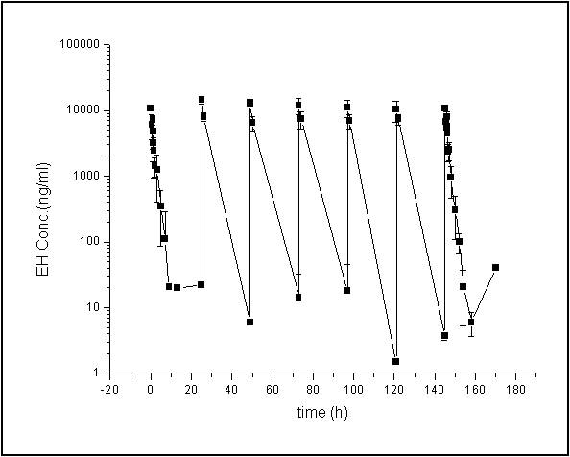

**图2-5 猕猴每天1次，连续7天静脉推注加滴注3.0 mg**·**kg-1 EH后**

**平均药时曲线（均值±标准差，n = 4）**

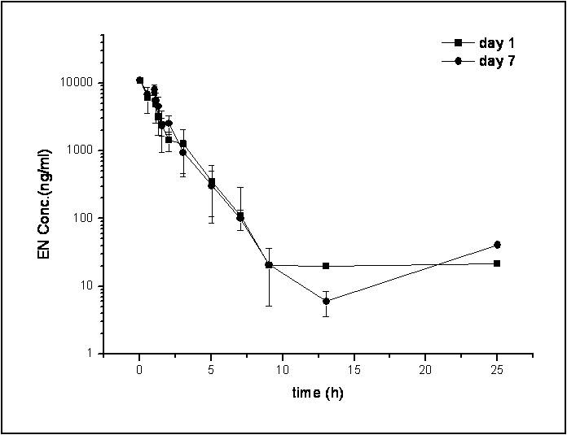

**图2-6 猕猴静脉推注加滴注3.0 mg**·**kg-1 EH，第1次和第7次的平均**

**药时曲线（均值±标准差，n=4）**

**表2-9 猕猴连续静脉推注加滴注3.0 mg**·**kg-1 EH首末次**

**平均药代动力学参数（n=4）**

|  |  |  |  |  |  |  |  |  |
| --- | --- | --- | --- | --- | --- | --- | --- | --- |
| 给药次数 | 参数 | 单位 | 1# | 2# | 3# | 4# | 均值±标准差 | P值vs.  首次 |
| 1次 | ke | 1·h-1 | 0.7 | 0.5 | 0.5 | 0.5 | 0.5±0.1 |  |
|  | ke_lower | h | 1.3 | 1.3 | 1.3 | 1.3 | 1.3±0.0 |  |
|  | ke_upper | h | 3.05 | 3.05 | 3.05 | 3.05 | 3.05±0.00 |  |
|  | t1/2 | h | 0.9 | 1.5 | 1.3 | 1.5 | 1.3±0.3 |  |
|  | Tmax | h | 0.05 | 0.05 | 0.05 | 0.05 | 0.05±0.00 |  |
|  | Cmax | ng·ml-1 | 10271.4 | 11850.2 | 10299.2 | 10575.1 | 10749.0±746.8 |  |
|  | AUClast | h·ng·ml-1 | 10283.4 | 17426.8 | 15655.3 | 10795.6 | 13540.3±3545.8 |  |
|  | AUCINF_obs | h·ng·ml-1 | 10300.4 | 17474.3 | 15692.5 | 10837.7 | 13576.2±3554.6 |  |
|  | Vz_obs | L·kg-1 | 0.4 | 0.4 | 0.4 | 0.6 | 0.4±0.1 |  |
|  | Cl_obs | L·h-1·kg-11 | 0.3 | 0.2 | 0.2 | 0.3 | 0.2±0.1 |  |
|  | MRTlast | h | 0.7 | 1.7 | 0.7 | 0.7 | 1.0±0.5 |  |
| 7次 | ke | 1·h-1 | 0.6 | 1.2 | 0.7 | 0.9 | 0.8±0.3 | 0.2 |
|  | ke_lower | h | 1.3 | 1.3 | 1.3 | 1.3 | 1.3±0.0 |  |
|  | ke_upper | h | 3.05 | 3.05 | 3.05 | 3.05 | 3.05±0.00 |  |
|  | t1/2 | h | 1.2 | 0.6 | 1.0 | 0.8 | 0.9±0.3 | 0.2 |
|  | Tmax | h | 0.05 | 0.05 | 0.05 | 0.05 | 0.05±0.00 |  |
|  | Cmax | ng·ml-1 | 11033.6 | 10964.5 | 11337.8 | 9856.1 | 10798.0±648.5 | 0.9 |
|  | AUClast | h·ng·ml-1 | 14194.0 | 16057.4 | 16995.6 | 12877.9 | 15031.2±1848.4 | 0.3 |
|  | AUCINF_obs | h·ng·ml-1 | 14222.6 | 16080.4 | 17092.8 | 12892.0 | 15072.0±1877.4 | 0.3 |
|  | Vz_obs | L·kg-1 | 0.4 | 0.2 | 0.3 | 0.3 | 0.3±0.1 | 0.1 |
|  | Cl_obs | L·h-1·kg-11 | 0.2 | 0.2 | 0.2 | 0.2 | 0.2±0.0 | 0.2 |
|  | MRTlast | h | 1.4 | 0.9 | 1.6 | 0.7 | 1.2±0.4 | 0.6 |
|  | Css,min | ng·ml-1 | ND | ND | ND | ND |  |  |
|  | Css,max | ng·ml-1 | 11033.6 | 10964.5 | 11337.8 | 9856.1 | 10798.0±648.5 |  |
|  | Cavg | ng·ml-1 | 591.4 | 669.1 | 708.1 | 536.6 | 626.3±77.0 |  |
|  | Fluctuation% | % | 1865.6 | 1638.8 | 1601.0 | 1836.8 | 1735.6±134.9 |  |
|  | Accumulation Index |  | 1.4 | 0.9 | 1.1 | 1.2 | 1.1±0.2 |  |

注：Css,min低于检测定量下限，计算Cavg时均以0计。

**7.3 猕猴连续静脉推注加滴注EH后的PT、APTT、TT及FIB监测**

猕猴连续7天每天一次静脉推注加滴注3.0 mg·kg-1 EH，末次给药后TT和APTT有所延长，4#猴尤其明显。但均于给药后1-2小时即恢复正常水平，PT及FIB水平无明显变化。

**表2-10 猕猴连续静脉推注加滴注3.0 mg**·**kg-1 EH 7天后TT、APTT、PT和FIB**

**变化情况（n=4）**

|  |  |  |  |  |  |  |  |  |  |
| --- | --- | --- | --- | --- | --- | --- | --- | --- | --- |
| **指标** | **单位** | **时间点** | **1#** | **2#** | **3#** | **4#** | **均值** | **标准差** | **P值** |
| **TT** | 秒 | 空白 | 11.8 | 11.6 | 13.1 | 11.2 | 11.93 | 0.82 |  |
| 空白-7 | 13.8 | 10.7 | 12.6 | 11.2 | 12.08 | 1.40 | 0.86 |
| iv后 | 15.8 | 15.3 | 16 | ＞300 | 86.78 | 142.15 | 0.00 |
| iv后1h | 14.3 | 12.3 | 12.5 | 19.1 | 14.55 | 3.16 | 0.22 |
| iv后2h | 14.5 | 12.6 | 14.1 | 10.1 | 12.83 | 1.99 | 0.45 |
| iv后4h | 13.8 | 9.8 | 16.7 | 12.8 | 13.28 | 2.85 | 0.42 |
| **APTT** | 秒 | 空白 | 24.5 | 24.7 | 25.8 | 25 | 25.00 | 0.57 |  |
| 空白-7 | 28.6 | 24 | 27 | 25.4 | 26.25 | 1.99 | 0.30 |
| iv后 | 33.9 | 31.5 | 30.8 | 148.5 | 61.18 | 58.23 | 0.01 |
| iv后1h | 28.8 | 27.1 | 27.6 | 78.9 | 40.60 | 25.54 | 0.01 |
| iv后2h | 28.5 | 26.3 | 27.8 | 21.8 | 26.10 | 3.01 | 0.52 |
| iv后4h | 28 | 20.3 | 28.4 | 29.3 | 26.50 | 4.17 | 0.53 |
| **PT** | 秒 | 空白 | 11.8 | 11.8 | 12 | 11.5 | 11.78 | 0.21 |  |
| 空白-7 | 14.2 | 11.4 | 11.4 | 12.3 | 12.33 | 1.32 | 0.47 |
| iv后 | 15.9 | 13.5 | 13.5 | 52.9 | 23.95 | 19.33 | 0.09 |
| iv后1h | 14.3 | 11.7 | 10.4 | 39.1 | 18.88 | 13.58 | 0.78 |
| iv后2h | 14.1 | 11.7 | 11.1 | 12.8 | 12.43 | 1.32 | 0.40 |
| iv后4h | 14 | 10.5 | 11.8 | 12 | 12.08 | 1.45 | 0.71 |
| **FIB** | g/L | 空白 | 2.74 | 3.12 | 3.04 | 3.15 | 3.01 | 0.19 |  |
| 空白-7 | 2.73 | 2.69 | 3.02 | 3.36 | 2.95 | 0.31 | 0.74 |
| iv后 | 2.65 | 2.64 | 3.27 | 3.73 | 3.07 | 0.53 | 0.54 |
| iv后1h | 2.93 | 3.06 | 3.45 | 3.74 | 3.30 | 0.37 | 0.51 |
| iv后2h | 2.59 | 2.92 | 3.09 | 3.39 | 3.00 | 0.33 | 0.94 |
| iv后4h | 2.68 | 3.69 | 2.37 | 2.78 | 2.88 | 0.57 | 0.68 |

注：阴影部分为超出仪器检测上限，因此按上限值300秒参与计算。P值为各时间点与首次空白组比较进行t检验结果。

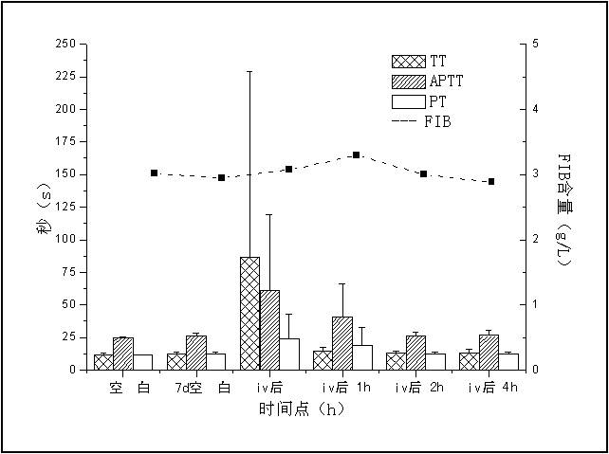

**图2-7 猕猴静脉推注加滴注3.0 mg**·**kg-1 EH 7天后体内TT、APTT、PT和FIB水平变化示意图（均值±标准差，n=4）**